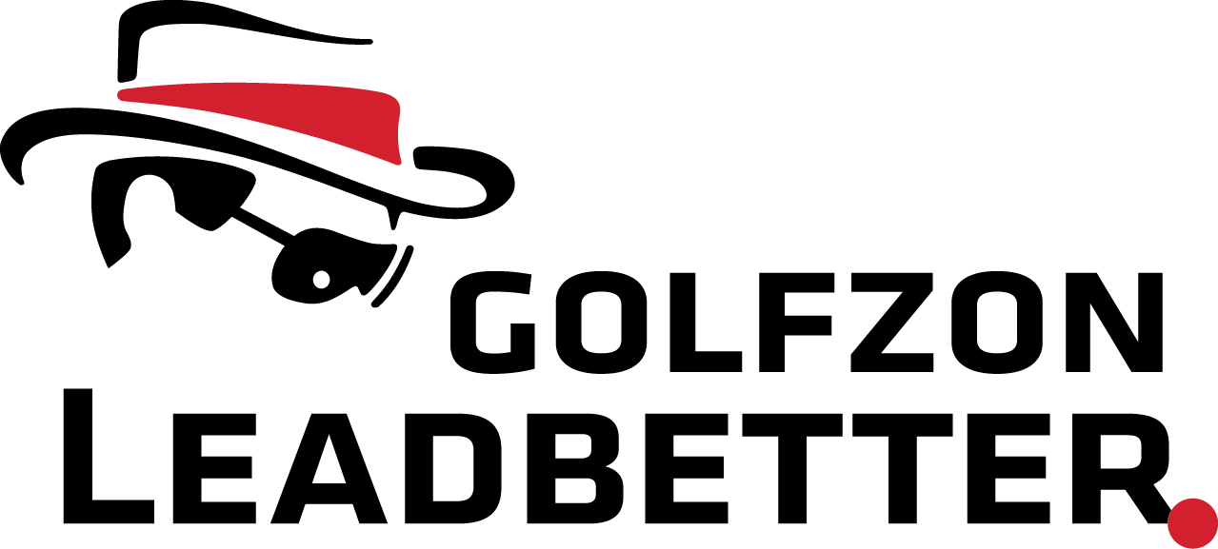

Title: Golf Instructor and Full Time Jr Coach

Company Mission:
To become the most loved golf academy worldwide building on the foundation David Leadbetter laid over 40 years ago.

Position
We are looking for a Golf Coach with a passion for helping elite junior golfers develop and fulfill their dream of playing in college and beyond. David Leadbetter established the first ever Junior Golf Academy in the world and this program is the continuation of that legacy to provide the best learning environment for junior golfers to make their goals a reality.

Leadbetter Instructor Training and Certification
- Instructors will be certified through to Golfzon Leadbetter Elite Instructor Program
- Online course and in-person training

Responsibilities and Duties
- Deliver golf instruction to junior golfers enrolled in the full-time junior program
- Manage player evaluation, development and coaching
- Attend junior tournaments supporting players
- Create tournament schedules
- Regular performance tracking and reporting
- Liaison and create a team approach with academy specialists in club fitting, fitness, biomechanics, mental training and course strategy
- Deliver week-long junior camps throughout the year and summer
- Deliver month-long pro development programs to young professionals and elite amateurs
- Opportunity to provide private instruction to individual clients ranging from elite players to the recreational adult outside Junior requirements.
- Actively create content and promote program on social media
- Assist in recruitment of new students and retention of current students
- Manage personal administrative duties associated with the role

Experience & Skills
- 7+ years experience in golf instruction
- Track record of developing golfers
- Experience using advanced teaching technology (launch monitors, 3D analysis, force-plates)
- Outstanding communications skills
- Actively engage with professional development training provided by academy

Location
Golfzon Leadbetter World Headquarters at Reunion Resort, FL

Compensation
- Full Time employment
- Competitive salary
- Commission on additional lessons, camps
- Healthcare and 401k
- Uniform and golf training equipment provided

Applications by: May 1st, 2023 to zach.p@golfzonleadbetter.com

